|  |  |  |
| --- | --- | --- |
| **المملكة العربية السعودية**  **وزارة التعليم العالي**  **جامعة الإمام محمد بن سعود الإسلامية**  **كلية علوم الحاسب والمعلومات** | **A description...**  **Second term 1441/2020** | **KINGDOM OF SAUDI ARABIA**  **Ministry of Higher Education**  **Al-Imam Mohammad University**  **College of Computer & Information Sciences** |
| **Software Engineering (CS- 310)**  **BSCS- Section: B**  **Project-Phase No: 1**  **Collage Tracking System**  **(Software Requirements Specification)** Submitted By | | |
| **Ahmed majed Alotaibi (438020712) – Coordinator****Fahad abdulaziz Alshaya(439016350)****Ibraheem saleh Altuwayjiri(439013074)****Mohammed khaled Alnasser (439014350)** **Khalid abdulaziz Alotaibi(439012737)** SupervisorDr.Sultan AlqahtaniDate: 22/2/2020 | | |

**Table of Contents**

1. Introduction 3

1.1 Purpose 3

1.2 Scope 3

1.3 Definitions, Acronyms, and Abbreviations 4

1.4 Overview 4

2. General Description 5

2.1 Product Perspective 5

2.2 Product Functions 5

2.3 User Characteristics 6

2.4 General Constraints 6

3. Specific Requirements 6

3.1 External Interface Requirements 7

3.1.1 User Interfaces 7

3.1.2 Hardware Interfaces 11

3.1.3 Software Interfaces 11

3.2 Functional Requirements 12

3.3 Non-Functional Requirements 20

4. Team Members Contributions 21

5. Conclusion 22

1. **Introduction**

This section is divided into subsections in which the first one describes the purpose of the project. The second and third subsections provide the scope of the project and the acronyms used, respectively. Finally, the last subsection lists the references used.

**1.1 Purpose**

In this SRS document, the project plan is described. The target of this project is also explained. In addition, the tasks of each team member of this project are presented. Moreover, the specifications and requirements of the project are presented.

**1.2 Scope**

The “college tracking system” is an application designed to help students and faculty staff to follow their schedule as well as their examination by offering a set of properties that include: classes location identification, teaching faculties schedules, emails, method of communications as well as office identification, also student’s examination schedule. This application also provides university map and GPS to help students tracking their classes. It will be free to download and use by people belong to college of computer science. College tracking system will not have access to student’s marks and will not be connected to university website. In addition to that, this application just operates within the university local area network (LAN).

**1.3 Definitions, Acronyms, and Abbreviations**

|  |  |
| --- | --- |
| Term | Definition |
| SRS | Software Requirement Specification |
| GPS | Global Positioning System |
| LAN | Local Area Network |
| CTS | College Tracking System |
| User | Anyone uses the application |

**1.4 Overview**

This document contains the system requirements specifications of the project and it is divided into sections. Section 2 provides a general description of the product in addition to the assumptions made and dependencies. Section 3 describes the specific requirements of the product which includes the external interface requirements and functional/ non-functional requirements. The contributions of each team member are given in section 5. Finally, section 6 concludes the document.

**2. General Description**

This section will give a general description about the product. Here the system will be described how it's interconnect with GPS system, in order to facilitate its functionality. In addition, it will describe the consumer base and what functionality will be used to them. Lastly, the user characteristics will be presented as well.

**2.1 Product Perspective**

CTS is a mobile software that will cooperates with GPS system. CTS mobile application will be used to locate and show real-time status of the desired classrooms or offices. Furthermore, our application will connect with the GPS to provide directions for the users to the designated room. CTS mobile application should present the contact information for the faculty staff along with the student's schedule information.

**2.2 Product Functions**

The CTS is a tracking system as well as service system. Using the application interface, it will help the faculty staff and student to direct them to their classroom. It allows faculty staff and student adding or removing a course from schedule, also faculty staff can add or remove their exams. Students will be directed to the scheduled classroom using their schedule. In addition, available classrooms will be colored differently than occupied or unavailable rooms. Furthermore, office rooms will display the office number and the staff information. Lastly, students and faculty staff can see a news list, which includes for example last uploaded exams or courses.

**2.3 User Characteristics**

There are three types of users that interact with the system: faculty staff, students and guests. For each of these three types of users have their different use of the system.

Faculty staff can use the application to add contact information, office number and classes schedule. Also, they can declare where the exams will be.

Students can use the application to add their classes schedule, they can receive alerts from the staff faculty, and they can search for classes, faculty staff and their information’s.

Visitors can use only the application to search for classes and faculty staff.

## **2.4 General Constraints**

Some limitations of using “Android studio” application, no previous experience on database designing and querying.

**3.1 External Interface Requirements**

The following subsections will examine the various pages that will represent the CTS.

**3.1.1 User interfaces**

The first-time user of the application will see the role pick page. The user should select his role by one of the roles, see Figure 1.

After selecting the role, the user will see the log-in page. User can log-in to this page, see Figure 2.

If the user doesn’t have an account, the user can sign-up by clicking the sign-up button. After that will open the sign-up page, see Figure 3.

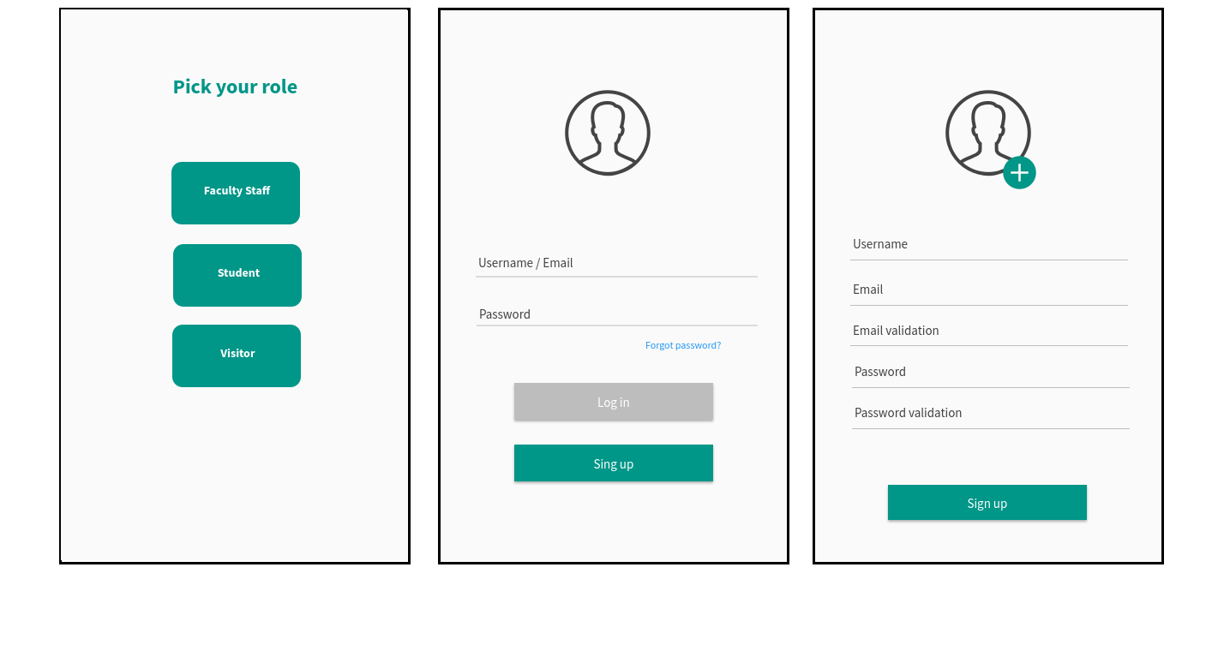

**Figure 1 – Role pick page**

**Figure 3 – Sign-up page**

**Figure 2 – Log-in page**

If the user can't remember the password, he can click "Forgot password?" on the sign-in page. It ‘ll lead the user to a page that asks the user to enter username and email, See figure 4

After the user entered his account, the home page will appear. It contains buttons that represent classrooms, faculty staff, exams, schedule, home, and me (user profile). See figure 5.

The classroom button opens a page that enables the user to search for classrooms. As a result of using the search bar, it 'll appear information about the classroom that have been searched like, the class number, floor number, and direction button that leads the user to its location, See Figure 6.

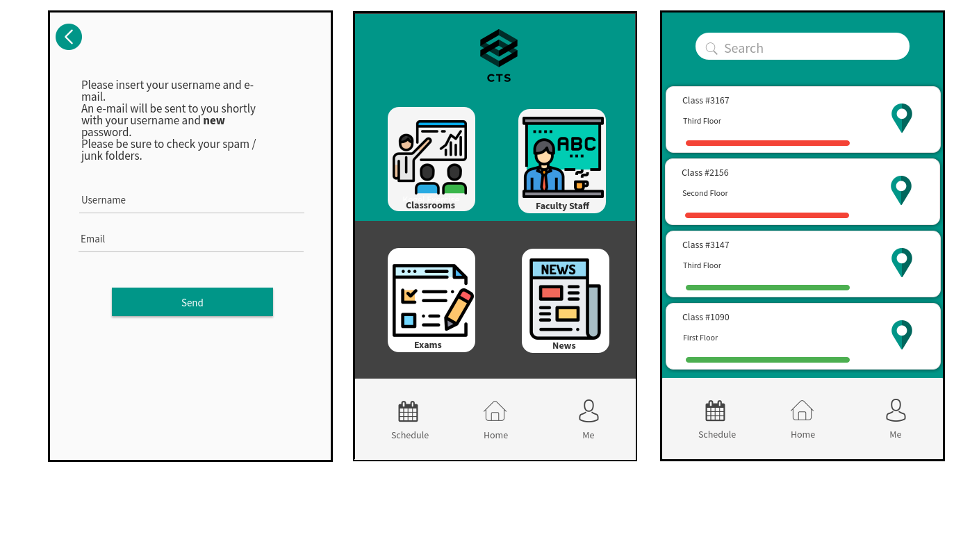

**Figure 6 – Classrooms page**

**Figure 4 – Forget password page**

**Figure 5 – Home page**

The faculty staff button will open a page that enables the user to search for faculty staff and their information. By using the search bar, it'll provide the result of faculty information that has been searched for, See figure 7.

The Exams button will open the page that can let the user see and search for exams. On the exams page, there is two buttons that can add and remove exams. Faculty staff user is the only user that can add and delete exams, See figure 8.

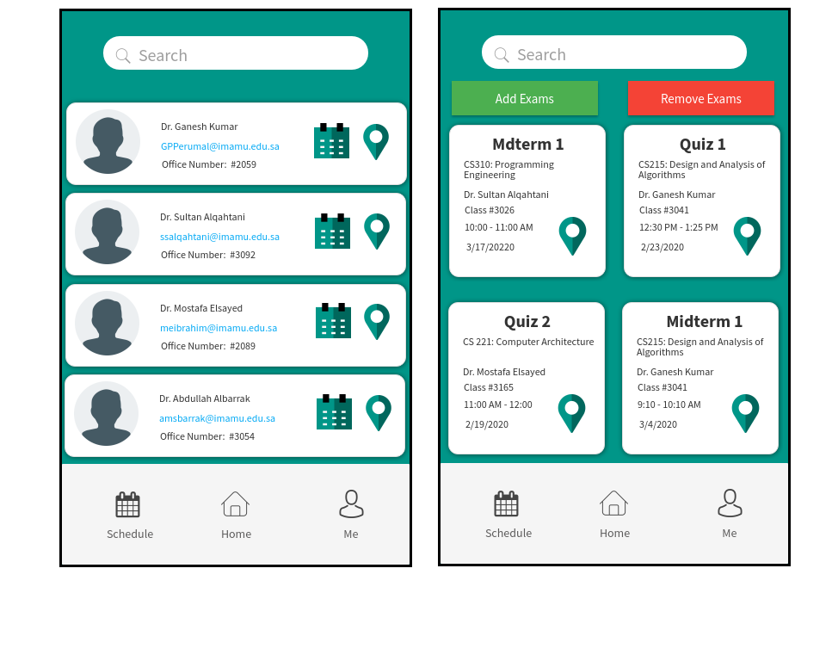

**Figure 7 – Faculty Staff page**

**Figure 8– Exams page**

The add exam button opens a page that lets the user add exams and its information, See figure 9.

The remove exam button opens a page that lets the user remove exams, See figure 10.

The News button on the home page opens a page that lets the user see the news, See figure 11. 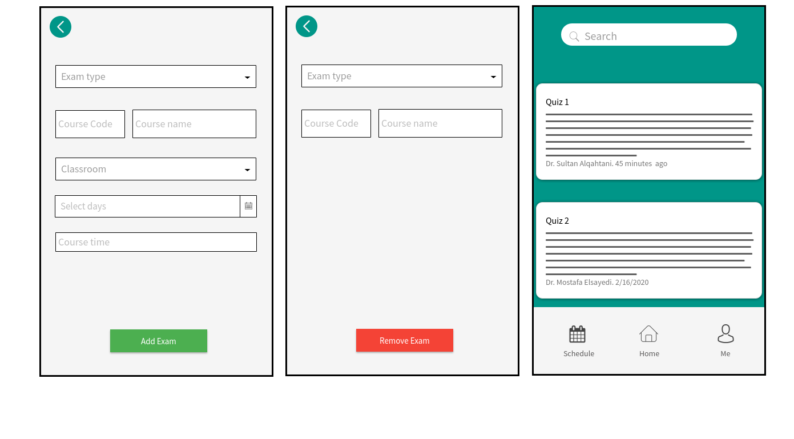

**Figure 10 – Remove exam page**

**Figure 9 – Add exam page**

**Figure 11 – News page**

Schedule button opens a page that lets the user add, remove and see schedule courses. There are two buttons on this page, See figure 12.

The first button is the add button. It enables the user to add course information and add it to schedule slut, See figure 13.

The second button is the remove button. It enables the user to remove a course by providing course code and course name, See figure 14.

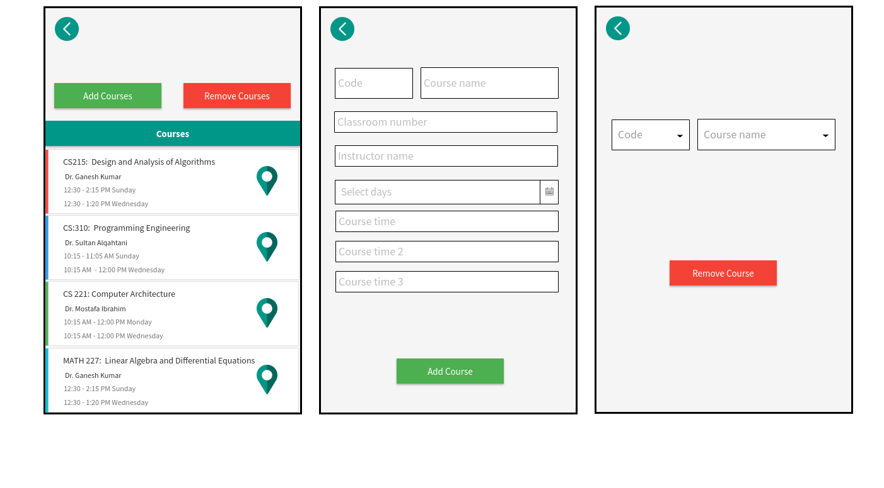

**Figure 14 – remove course page**

**Figure 13 – add course page**

**Figure 12 – Schedule page**

The Me button on the home page opens the profile page. The page contains user information. The user can edit the information by clicking the edit button and he can log-out by clicking the log-out button, See figure 15. Edit button opens a page

that enables the user to edit his information, See figure 16.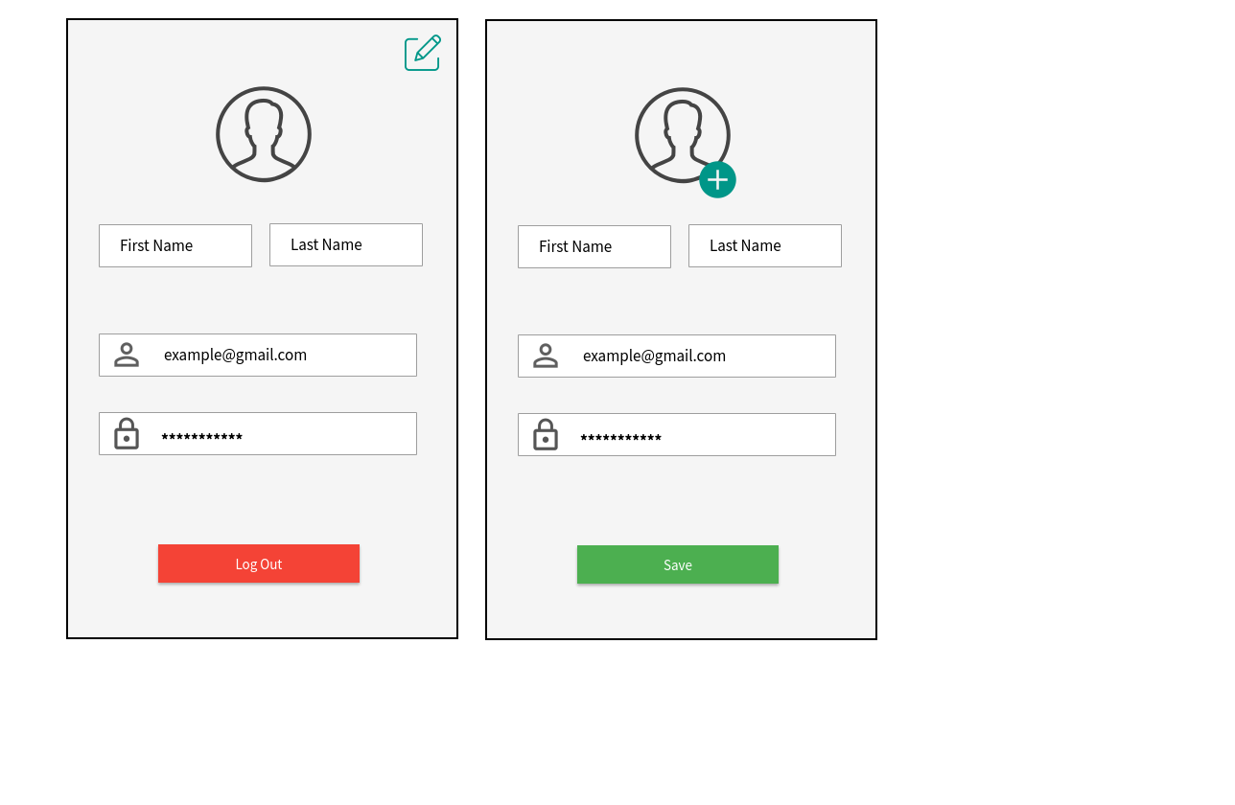

**Figure 16 – Edit me page**

**Figure 15 – Me page**

**3.1.2 Hardware interfaces**

This application works on Android mobiles and Android tablets. No other hardware is required.

**3.1.2 Software interfaces**

Since this application is a mobile application, it will only need an Android version 8.0 or higher in order to perform probably.

**3.1.3 Communication interfaces**

The application communicates with the GPS application to provide a geographical information about the user location and to direct user to it destination.